CPE301 – SPRING 2019

Design Assignment 2C

Student Name: Tyler Gardenhire

Student #: 8000450294

Student Email: gardenhi@unlv.nevada.edu

Primary Github address: [gardenhi@unlv.nevada.edu](mailto:gardenhi@unlv.nevada.edu)

Directory: https://github.com/tylergardenhire/submission_projects.git

Submit the following for all Labs:

1. In the document, for each task submit the modified or included code (only) with highlights and justifications of the modifications. Also, include the comments.
2. Use the previously create a Github repository with a random name (no CPE/301, Lastname, Firstname). Place all labs under the root folder ESD301/DA, sub-folder named LABXX, with one document and one video link file for each lab, place modified asm/c files named as LabXX-TYY.asm/c.
3. If multiple asm/c files or other libraries are used, create a folder LabXX-TYY and place these files inside the folder.
4. The folder should have a) Word document (see template), b) source code file(s) and other include files, c) text file with youtube video links (see template).

1. **COMPONENTS LIST AND CONNECTION BLOCK DIAGRAM w/ PINS**

Atmel Studio 7 w/ AVR assembly and simulator and Atmega328p board used.

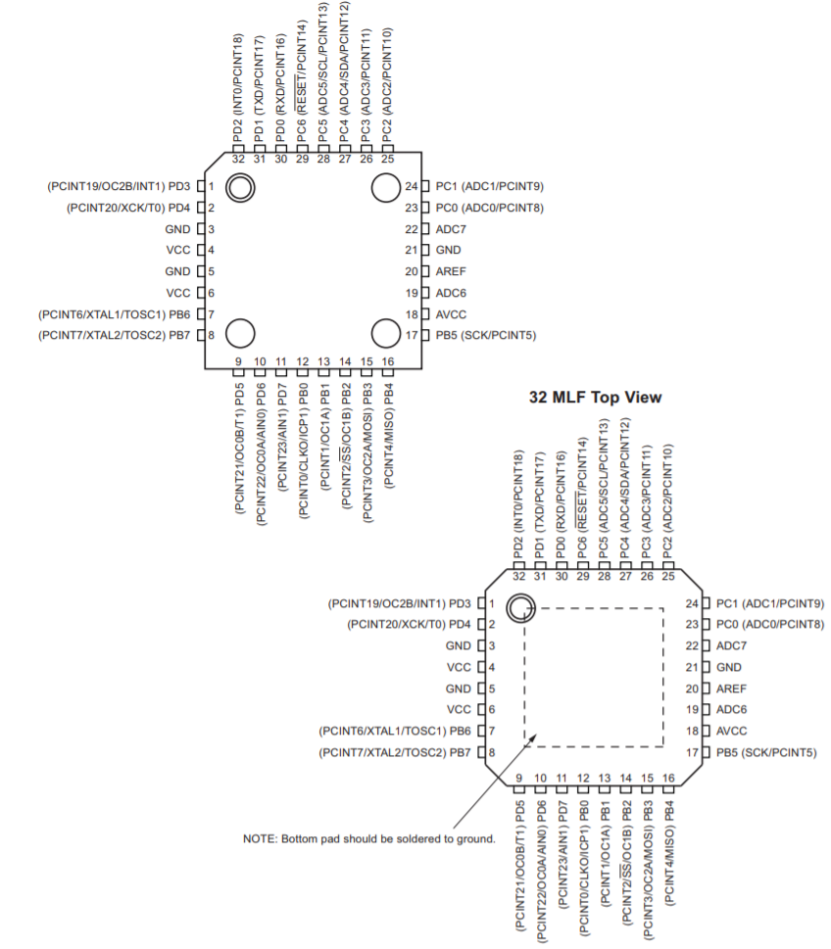

PortB2 is connected to LED3 and PortC2 is connected to SW1.

1. **INITIAL/MODIFIED/DEVELOPED CODE OF TASK 1/A**

Task 1 C code:

#define *F_CPU* 8000000UL

#include <avr/io.h>

#include <util/delay.h>

int main(void)

{

DDRB |= (1 << DDB2); //pb2 as output

TCCR0A = 0; //normal operation

TCNT0 = 0x00; //start the timer

TCCR0B |= (1<<CS01) | (1<<CS00); //set prescaler to 64 and start the timer

while (1)

{

while ((TIFR0 & 0x01)==0);

PORTB ^= (1<<DDB1);

TCNT0 = 0x00;

TIFR0 = 0x01; //reset the overflow flag

}

}

Task 2 C code:

# define *F_CPU* 8000000UL

#include <avr/io.h>

#include <util/delay.h>

#include <avr/interrupt.h>

int main(void)

{

DDRB |= (1 << DDB2); //pb2 as output

TIMSK0 |= (1 << TOIE0);

TCNT0 = 56; //initial value

sei(); //enable interrupts

TCCR0B |= (1 << CS01) | (1 << CS00); //set prescaler to 64 and start the timer

while (1)

{

//main loop

}

}

ISR (TIMER0_OVF_vect) //timer0 overflow interrupt

{

TCNT0 = 56;

PORTB ^= (1 << DDB1);

}

Task 3 C code:

#include <avr/io.h>

#include <avr/interrupt.h>

int main(void)

{

DDRB |= (1 << DDB2); //pb2 as output

OCR0A = 40;

TCCR0B |= (1 << CS01 | 1 << CS00); //internal clock

TCCR0A |= (1 << WGM01); //internal clock, ctc mode, no prescaler

sei();

while (1)

{

//wait here

}

}

ISR (TIMER0_COMPA_vect)

{

PORTB ^= 0x02; //toggle PORTB.2

TIFR0 |= (1 << OCF0A); //clear the compare A match flag

}

1. **DEVELOPED MODIFIED CODE OF TASK 2/A from TASK 1/A**

N/A

1. **SCHEMATICS**

N/A

1. **SCREENSHOTS OF EACH TASK OUTPUT (ATMEL STUDIO OUTPUT)**

Task 1:

Full period is 725 ms, the following screenshot was taken at the end of one loop.

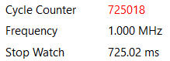

Task 2:

Full period is 725 ms, the following screenshot was taken at the end of one loop.



Task 3:

Full period is 725 ms, the following screenshot was taken at the end of one loop.



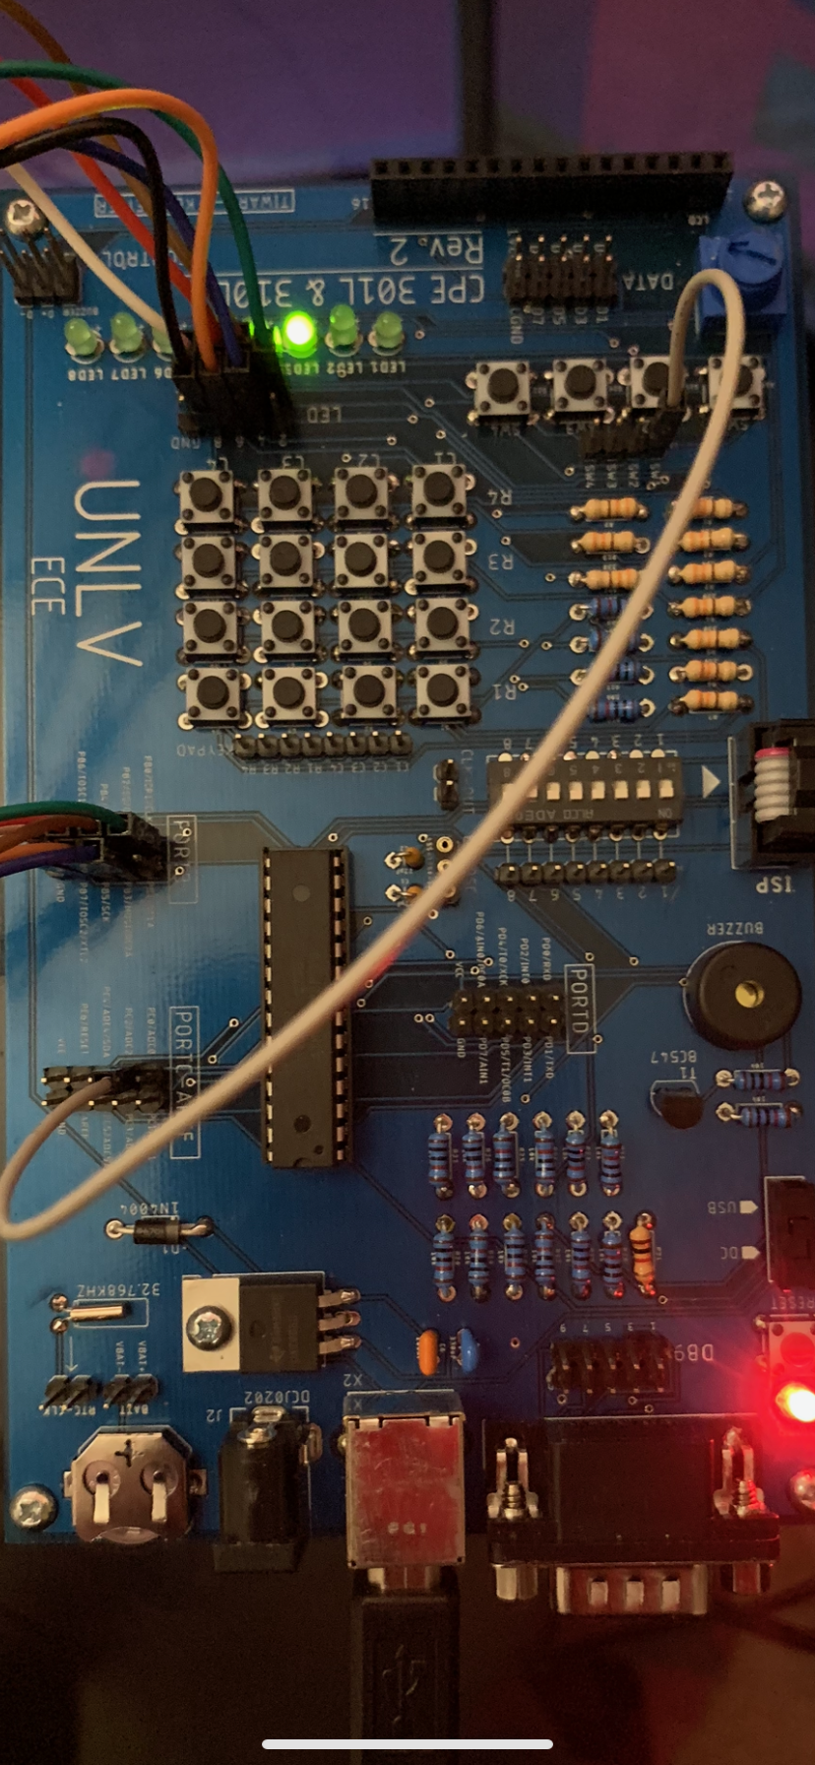

1. **SCREENSHOT OF EACH DEMO (BOARD SETUP)**
2. **VIDEO LINKS OF EACH DEMO**

<https://youtu.be/ccK8sL_Mcg4>

1. **GITHUB LINK OF THIS DA**

https://github.com/tylergardenhire/submission_projects.git

**Student Academic Misconduct Policy**

<http://studentconduct.unlv.edu/misconduct/policy.html>

“This assignment submission is my own, original work”.

TYLER GARDENHIRE